Navigating the Storm: Why Climate Anxiety is Real, But So is Hope

By Farah Hina | Chair of Cambridge Open University Psychological Society (COUPS | 2025-26)

I recently had the privilege of leading the Cambridge OUPS webinar, The Climate–Mind Connection: From Awareness to Action. Our audience came together to explore an important topic; the intersection of climate change and mental well-being.

Over two hours, our panel went beyond headlines, sharing practical insights on managing eco-anxiety, building resilience, and taking meaningful action. The discussion highlighted that while climate concerns are real and can feel overwhelming, there are ways to cope, connect, and contribute to solutions. The key takeaway was clear: understanding the link between mind and environment empowers us, and small actions can make a difference.

Below is a snapshot of the how the webinar unfolded, along with insights from each speaker’s talk that brought the session to life:

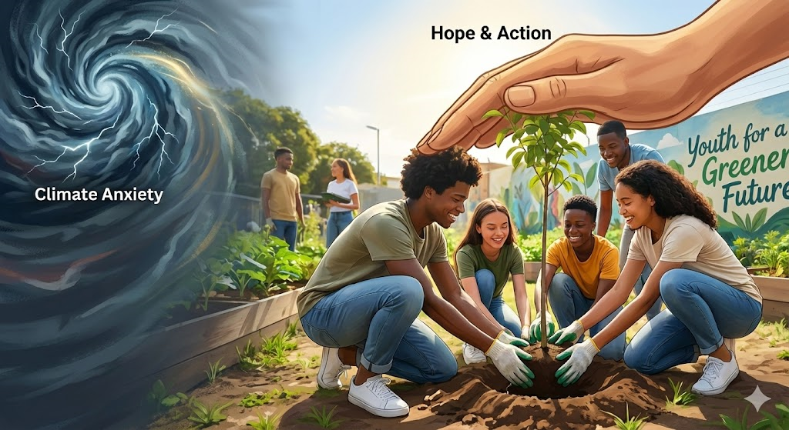

1. Climate Change and mental health through a scientific lens

The webinar began with a scientific perspective from Dr. Abeer Albdour (University of Birmingham), who explored how extreme temperatures and air pollution affect mental health. Reviewing studies, she highlighted links between heat, cold, pollution, and rises in psychiatric admissions, depression, anxiety, and schizophrenia. Vulnerable groups include older adults, children, and those on psychiatric medications, which can be affected by heat.

Research gaps remain, especially in the UK, where local data is lacking. Dr. Albdour’s ongoing work will analyse UK health records to guide public health strategies, showing how climate change directly impacts mental well-being and service demand.

Key takeaway: understanding environmental stressors is crucial for protecting mental health and building community resilience.

2. Find Your Anchors (and look for the Blue)

Isaac Kenyon, eco-adventurer and mental health advocate brings a vivid, lived perspective to climate and mental health. From rowing across the Atlantic to cycling through deserts, he has faced nature’s extremes and sees a mirror in the unpredictability of eco-anxiety. He shared how connection with nature, purpose, and community can anchor the mind, showing that even small moments - watching a squirrel, noticing a tree, or standing by water can ground us. The concept of “blue space” stood out: lakes, rivers, and the sea can be even more calming than green spaces.

His key message: we cannot control the storms, but we can steer our course, shape our mindset, and take small actions that build hope, resilience, and a sense of meaning.

3. Youth Are Makers, Not Just Victims

From Isaac’s eco-adventures to climate action, Dr. Mohsen Gul (sustainability leader and systems curator) highlights young people feel the weight of climate change everywhere; from New York to Nepal, Mexico to Brazil. Floods, heatwaves, and food insecurity shape their lives, sparking anxiety but they don’t just worry, they act. Some are pioneering climate-smart agriculture, others are developing technology to conserve land, advocating for indigenous rights, or pushing for climate education. What holds them back isn’t imagination; it’s opportunity. With the right mentorship, resources, and supportive spaces, their ideas become solutions.
Obstacles remain: limited funding, systemic inequities, and burnout remain, but guidance and safe spaces help them persevere. As Dr. Mohsen Gul reminds us, “Every job can be green, every initiative can spark change.” You don’t need a “climate” job title to make a difference; you just need to find the green angle in the work you already do, turning concern into action, and building resilience, creativity, and hope along the way.

4. Turning Climate Concern into Action: A New Guide for Conversations

Building on the energy Mohsen Gul highlighted about youth action, Amanda Cole (retired clinical psychologist and CBT expert) shared highlights from the BABCP Climate Conversations Guide, emphasizing that climate-related emotions: anxiety, grief, anger are natural and valid. Rather than trying to remove these feelings, the guide helps people embrace them and channel them into meaningful action. Using CBT principles, it provides strategies for navigating conversations about climate change - at home, in therapy, or across communities. The guide also encourages small actions that ripple outward, fostering resilience, creativity, and sustained engagement. By including real-life experiences and 3rd-wave techniques like ACT and compassion-focused work, it equips practitioners and everyone to translate eco-anxiety into constructive dialogue and tangible solutions.
Closing remarks:
To close, I would like to share the post-event survey that offered a glimpse into how participants experienced the webinar and what resonated most with them. It clearly made a powerful impact. Attendees praised the clarity of communication and the engaging presentations, including inspiring personal experiences and insights on youth-led climate action. Many reported a noticeable increase in awareness on the intersection of climate change and wellbeing. A few also shared concrete ways they plan to respond on the call for action, for instance, taking part in activism, sparking political conversations, creating safe spaces for dialogue, and connecting diverse communities to drive change.
Acknowledgments
I would like to extend my deepest gratitude to our inspiring guest speakers: Dr. Abeer Albdour, Isaac Kenyon, Dr. Mohsen Gul, and Amanda Cole for sharing their time, insights, and stories with us.
A huge thank you to the COUPS committee: Alan Pechey, Denise Ward, and Diane Michelson, and to Sarah Harwood, OUPS Chair - for all their hard work in making today possible.
Finally, thank you to everyone who attended. Let's hold on to the hope that comes from "rowing together."

